Pi Kappa Alpha
Alumni Mentor Launch Guide
August 2018

Alumni Mentoring - Foreword
This document is provided so chapters, colonies, and alumni associations who desire to fully implement alumni mentoring, as a component of the True PIKE Experience, will have the resources, suggestions, and knowledge to do so. It is meant to be interpreted as a “launch guide” which will help you start a program from the ground up.

This document is not meant to be an exhaustive list of every mentoring possibility for the undergraduate member. Rather, this document is created to be a baseline starting point for alumni associations and chapter leadership to get the program off of the ground. This document is also not meant to explain the ideology or to be a pedantic guide of mentoring as a discipline. For that, please see the True PIKE Experience Mentor Program – Handbook, located in the myPIKE Resource Center.

Table of Contents
Alumni Mentoring Basics 1
Why Now? 1
Alumni Mentoring as Part of the True PIKE Experience 2
Step 1: Assemble the Leadership Team 3
Alumnus Position 3
Undergraduate Position 3
Step 2: Set the Expectations for the Program 4
Sample Expectations 4
Step 3: Gather Information from Alumni and Undergraduates 5
Step 4: Match Mentors to Mentees and Facilitate Introduction 7
Introduction Event 7
Step 5: Cultivate and Re-engage Relationships 9
Cultivate 9
Re-engaging Relationships 9
Step 6: Solicit Feedback and Transition 10
Feedback 10
Transition 10
Notes 11

Alumni Mentoring Basics
One of the most common requests from collegiate members to fraternities, universities, or other organizations is a desire for a mentor relationship. Universities are beginning to try to implement mentor relationships on a large scale – with varying degrees of success. Greek organizations, and Pi Kappa Alpha specifically, have a unique opportunity to provide mentorship to their undergraduate membership through alumni. The biggest challenge in the mentor-mentee relationship is finding common ground. Being a PIKE immediately addresses that and can help launch a long and fruitful relationship.

The degree of the mentor-mentee relationship, like a lot of things, will vary greatly depending on the individuals involved. For some, the mentor-mentee will meet on a weekly basis and talk about every aspect of life. For others, it might only be once a month. Both of these two options are fine, as long as both sides are happy with the frequency and that the expectations of the relationship are being met.

Why Now?
Pi Kappa Alpha chapters, and even alumni, have long been touting the benefits of joining a fraternity. Among these commonly mentioned benefits is access to alumni across the country or even access to alumni mentorship as an undergraduate. Some alumni can think of one or two brothers that have made an impact on their lives or career. However, for others they have never had the opportunity to have mentorship from an alumnus or receive a tangible impact. While this guide is not meant to be a mentoring solution across the country, it can be used at the local level to create a positive and meaningful program.

In addition to providing support and growth to our undergraduates, college students want to see the value or purpose in what they are doing. While fraternities have intrinsic value and purpose, the newest generation wants to be able to tangibly see those values and return on investment they are going to get. This is why mentoring is highly demanded by the current generation. They want to hear and learn from your experiences. They want something more out of their fraternity experience. They want to make a difference.

With your help, and the strategic implementation of a mentoring program, we can provide that value to today’s collegiate man and make good on recruitment promises that for too long have not been honored.

Alumni Mentoring as Part of the True PIKE Experience
The True PIKE Experience is Pi Kappa Alpha’s holistic membership development program which is designed to take education and learning both beyond the classroom and beyond the new-member period. As 2018 International President Mark Dziatczak says “Pi Kappa Alpha is the leadership laboratory of the 21st century”. As with any lab, there needs to be guides and experienced people to help the “experiment” go well. That is why mentoring is such a huge aspect of the True PIKE Experience.

While this piece will largely focus on alumni mentoring, it is important to note how the mentoring cycle integrates with the True PIKE Experience.

The above diagram illustrates the timeline for freshman and sophomore undergraduates. As a new-member, they will be assigned a Junior member (Fraternity Leader) who will then be their mentor for the next two years. At that point, the original new-member, who is now a junior, will mentor a freshman and be assigned an alumnus mentor.

Step 1: Assemble the Leadership Team

As with any chapter or alumni programming, a leadership team will need to be assembled to execute the program. In this case, since it is a joint effort, both alumni and undergraduates should be on the leadership team.

Alumnus Position
It is recommended that the following position exist on the alumni association:

Alumni Mentoring Liaison:

The alumni mentoring liaison will work directly with the respective undergraduate position, the mentoring chairman, to coordinate the facilitation of the program.

Responsibilities include:
- Identifying alumni talent pool
- Sending out mentoring questionnaires to alumnus members
- Helping to match alumnus members with undergraduate members of similar interests
- Collect feedback from participants

Undergraduate Position
It is recommended that the undergraduate position, the Mentoring Chairman, serve under the alumni relations chairman in the Internal cabinet.

Mentoring Chairman:

The mentoring chairman will help facilitate the assignment of mentors to junior and senior members in the chapter. The mentoring chairman will work directly with the alumni mentoring liaison to match mentors and mentees.

Responsibilities include:
- Creating member profiles to pass to alumni mentoring liaison (major, hobbies, hometown, etc)
- Working with the alumni mentoring liaison on the alumni association to assign mentors to mentees
- Facilitating introductions and contact information of mentor to undergraduates
- Ensuring that the chapter members are putting forth the commitment to the program
- Collecting feedback from undergraduates

Successfully implementing an alumnus mentoring program will only happen with both the undergraduate chapter and the alumni association are on the same page. This is most easily accomplished by setting clear expectations and a shared vision for what the program will look like.

Step 2: Set the Expectations for the Program

As with any relationship, the expectations and communication must be consistent for the relationship to thrive. This is easily seen with the relationship between the chapter leadership and the chapter’s alumni advisory board. When expectations between the two parties do not align, the relationship will quickly sour - to the detriment of both parties.

The actual expectations of each mentor-mentee relationship will be determined by the two parties involved; however, the chapter and alumni association should come to a consensus about what framework the program will have.

Sample Expectations

Communication Medium

The mentor and mentee will meet in person at least once per semester and use video chat (Facetime, Google Hangout, Skype) for all other communications. If that is not possible, then a phone call will suffice.

Communication Frequency

The mentor and mentee will communicate via video chat at least once per month and on an as-needed basis to supplement that.

Mutual Respect and Openness

Any positive relationship is based on mutual respect and the mentor and mentee will strive to always uphold that in their relationship. In addition, both parties should try to be as open as possible with each other to ensure that a positive dialogue and true advice can occur

Commitment

The True PIKE Experience mentor program, of which an alumni mentor program is a part of, recommends that the same alumnus mentor be assigned to the same member as he progresses through his junior and senior year. This will take commitment from both parties to see the relationship through two academic terms and a summer break.

Step 3: Gather Information from Alumni and Undergraduates

The best way to initiate a mentor-mentee relationship is by assigning mentors with undergraduates that have similar interests. These interests can be academic, similar hobbies, similar career paths, hometown, etc. Anything that can be done to match these interests will certainly help foster the initial relationship and give the mentor and mentee something to bond over.
In order to match these interests, it is recommended to survey both the alumni who are interested in mentoring and the undergraduates in order to create a “profile” for each person. While you can print off an info sheet and collect information that way, an easy way would to create an online form, through Google Forms or other service, to collect the information remotely and digitally.
Information to collect for matching:
- Major
- Career Aspirations
- Graduate school plans
- Hometown
- Hobbies
- Clubs/Activities
- Pi Kappa Alpha Positions held
Once this information is collecting, you can easily match interests in an excel spreadsheet by sorting the information in a way that is useful for you. Please see the following page for a sample form to use to gather information.
On this form, it might also be useful to have a short answer section where both the undergraduates and alumni can discuss what they want out of the program and provide background information that form answers are unable to convey. This is a good way to provide information that can be used to start the relationship. Additionally, having a personal statement can be used to re-engage mentors with mentees should the relationship begin to drift apart. Short answer questions could include:
- What qualities are you looking for in a mentor?
- Why do you think mentoring is important?
- What do you hope to get out of the mentoring relationship?
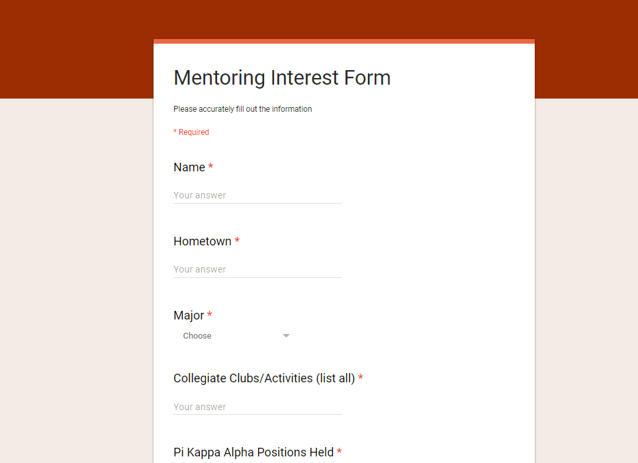

Step 4: Match Mentors to Mentees and Facilitate Introduction
The next step, after collecting the information is to actually begin the mentor matchmaking process.

As mentioned in the previous section, if you can collect all the information electronically, then the information should automatically be in a spreadsheet. If not, then it might be worth taking the time to enter in the responses into a spreadsheet – especially with a larger chapter. Once all that information is entered, it is recommended that the alumni mentoring liaison and the undergraduate mentoring chairman sit down and discuss the following:

- What is the primary matching criteria going to be? Hometown, Major, PIKE position? There are a number of fields to choose from and it is important to come to a consensus as to what will be the most important one to begin to match from. For some regional and state schools, that might be hometown while for others it might be what major or professional school they are in or want to attend. Once you decide what the primary criteria is going to be you can begin matching mentors with mentees and then move on to secondary or tertiary criteria after that.

- What is the best way to facilitate introductions? It is important that both the alumni mentoring liaison and the undergraduate mentoring chairman agree on the best way to facilitate an introduction between the two parties. For many chapters, this will likely be done in the fall semester during the Homecoming weekend. However for chapters that are more remote, a video conference might be the best way to facilitate the introduction.

Introduction Event
The best introductions and relationships are built face to face. While this might be difficult for every mentor and mentee, it is an important show of commitment to the program for both parties to be there in person. For many chapters, it makes sense to put the introduction event around an already popular alumni event since alumni who take the time to show-up to an alumni event are likely also willing to serve as a mentor.

It is recommended that the mentor and mentee already have been introduced to each other over e-mail with the “profile” of the two individuals shared between and allow each party to learn more about each other. From there, the chapter should purchase nametags at the event to allow for easier identification. The chapter/alumni associations should adhere to the following do’s and don’ts of the introduction event:

Do:
- Provide a casual and quiet space for the alumni and undergraduates to mingle
- Provide non-alcoholic refreshments
- Have the president and alumni mentoring chairman speak about the purpose of the program and what they hope to get out of it
- Provide one-sheeter resources on mentoring
- Remind everyone about the shared responsibility to maintain the relationship
- Have an alumni share a mentoring success story if possible
- Be prepared to answer questions
- Prepare the chapter with talking points to their alumni

Don’t:
- Have the event at a tailgate
- Have alcohol available at the event
- Invite chapter members who are not receiving an alumnus mentor to the event
- Plan the event in a week
- Be unprepared

As mentioned in the “do” section above, it is important that the chapter president and alumni association mentoring liaison speak to both the undergraduates and alumni to emphasize the expectations of the program. While expectations can be communicated via other medium, the introduction event might be the only time that both groups will be together in the same place at the same time to hear them.

After the mentee/mentor have been introduced, give them time to mingle at the location of the event. It is best that this event is not late at night so that brothers will not be distracted as this is a professional mentoring relationship.

Sample Agenda:

5 minutes – Introduction of Chapter President, Mentoring Chairman, and AA Mentoring Liaison

15 minutes – Describe mentoring process, the reason why the program is being implemented

5 minutes – describe expectations for Mentors and Mentees

10 minutes – answer questions from those in attendance

Remainder of time – have the mentor and mentee get to know each other

Step 5: Cultivate and Re-engage Relationships
After the mentors and mentees have met, an introduction has been facilitated, and their mentoring relationship has begun it becomes important to track and continue to encourage the relationship. Humans get busy, and it can become easy to put commitments to the backburner and forget about them. The role of the mentoring chairman and mentoring liaison is to bring the commitment that both parties made to each other back to forefront.

Cultivate
It is recommended that the mentoring chair and mentoring liaison set up a recurring reminder e-mail to all participants on a monthly or bi-monthly basis. This way the reminders are being actively sent as opposed to passively reminded at chapter meetings. Scheduling an email through an online webmail service such as MailChimp is easy and once you set the e-mail schedule, you can forget about it.

Additionally, for those chapters that are close geographically to where a majority of the mentors live, it is also recommended to host quarterly mentor meet-ups where the chapter or association hosts an event. This can be a watch party, a cook-out, or other event that will draw the alumnus mentors back to campus to meet face to face with their mentee.

Re-engaging Relationships
It is likely that no matter how many reminders or cultivation events occur, one or two mentor-mentee relationships will begin to fall apart and will need to be resuscitated. In order to do this, it helps to remind the individuals of why the decided to be a mentor or what the mentee can gain out of the relationship. Ideally, this information was collected in the Mentor Interest Form so it can be used to try to re-engage the relationship.

If efforts to re-start the relationship repeatedly fail, it then becomes time to pull another alumnus member off the bench or hold the undergraduate accountable to maintaining the relationship. However, sometimes, it is best for both parties to end the relationship and move on. In this case, both the mentoring chairman and alumni mentoring liaison should be notified as to why the relationship ended.

Step 6: Solicit Feedback and Transition

As with any program, it is important to gather feedback on what didn’t work, what did work, and prepare to transition the next person into the role. In a perfect world, the alumni mentoring liaison will hold the position for multiple years so that he can be a source of knowledge and continuity as new Junior classes begin to matriculate into the program. On the undergraduate level, it is likely that a new mentoring chairman will be in place each year. It is important to have feedback and a transition in place.

Feedback
Create a feedback form, which can either be a physical or a digital form, to distribute to those that have participated. It is recommended to have two different feedback forms: one for those transitioning from Junior year to Senior year and one for those who are matriculating out after their senior year.

Things to include on the form include the following:

- How many times did you communicate with your mentor/mentee per month?
- What medium worked best to communicate?
- How many times did you meet in person?
- What was the primary mentoring topic (personal, professional, academic, etc.)?
- What did you like about the program?
- What, specifically, would you change about the program?
- Was the introduction to your mentor properly facilitated?

However, feel free to add what you feel is necessary to the feedback form. After this has been collected, it is important to process the responses, take notes of any recurring themes, and propose changes to the next cycle of mentoring that can address any concerns. Keep the feedback stored electronically or in the cloud so that future mentoring chairman and alumni mentoring liaisons can look through in the future.

Transition
Prepare a transition for the incoming officers. If it is just the undergraduate chairman that is turning over then have both the incoming and outgoing mentoring chairman in attendance along with the alumni mentoring liaison from the alumni association. This is important because the program is only as successful as the relationship between the chapter and the alumni association.

For the transition, the outgoing chairman should be prepared with any documentation that he used during his time (mentoring information sheet, feedback form, budgets, etc). The mentoring team should then objectively assess the current state of the program using a SWOT (Strengths, Weakness, Opportunity, Threats). The outgoing chairman should also provide his suggestions for the position and say what he wished he could have done differently. For more information on how to properly transition, see the “Strategic Planning Guide” on pikes.org.

Notes

