AA Sample Communication Plan

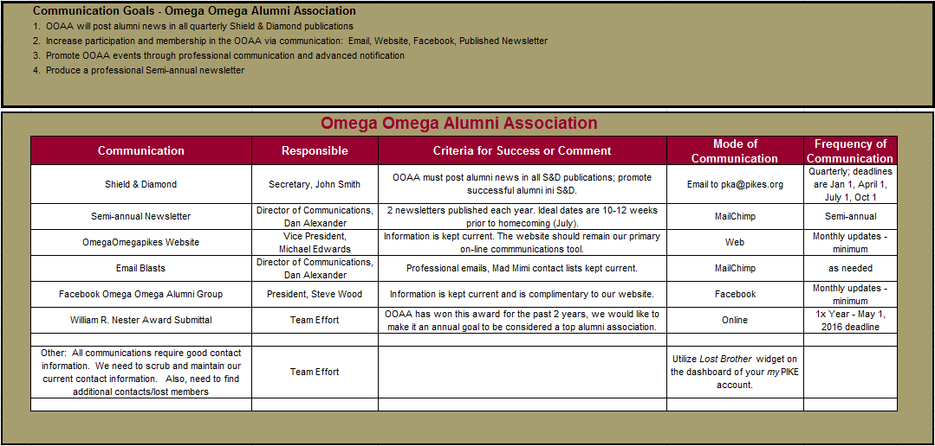
The Zeta Chi Alumni Association has come up with a sample communication plan as seen below. This is a great way for the Director of Communications to delegate tasks, so that the alumni association may communicate effectively and efficiently. The model below may also be adapted for other goals within the alumni association.

